|  |
| --- |
| G 19HOUSE OF ALBUMS |

# MEMBERS NAMES

* Mahmoud adel ismael
* Nourhan abo elsoud abd elhamed

# SUPERVISORS NAMES

## •Dr. Weal Zakaria •Dr. Mohamed Hashem

With this database you can collect data about:

|  |
| --- |
| PROBLEM STATEMENT AND  THE IMPORTANCE OF YOUR DATABASE |

* Artist'name , birthdate , id, start date and number of weeks that he was the top evah ew tub ,100 tnednepedni dna tnadneped sdnik owt
* Albums ‘s name , id , and when it was released
* Adunie’s phone , age and email
* Genre we have multiple kinds like romantic and we can know the kind and id

CONTINUE.

Adunie who can rate the album or the artists , we can know about them Thier age , phone and e-mail

Record-label the company who works with the artists we can know about them total artists and their date of establish.

## RATIONAL SCHEMA

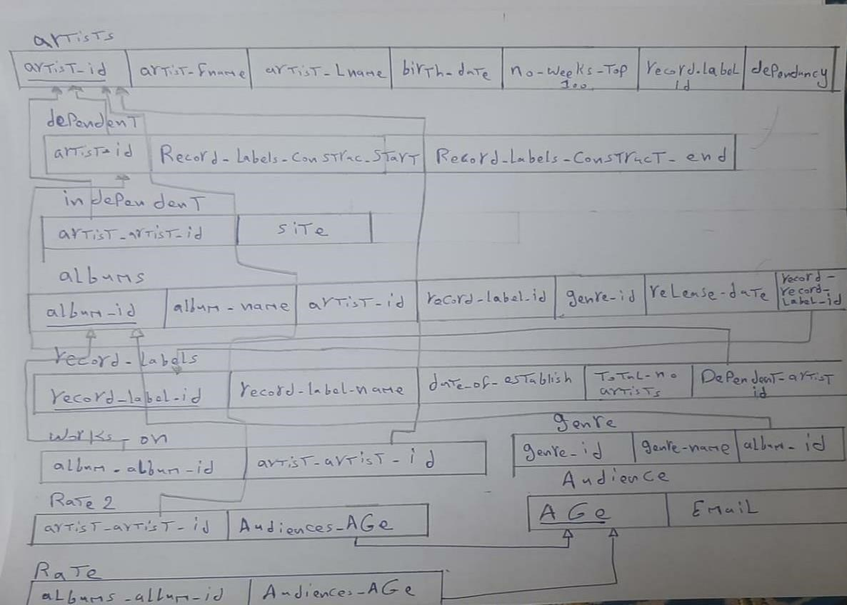

# EER

